Chapter 4: Biological Molecules

4.1 Chemicals and Life
Living organisms are composed of various biological molecules, primarily carbohydrates, fats (lipids), and proteins. These organic molecules are fundamental to life processes and are built from specific chemical elements.

Chemical Elements in Biological Molecules
All organic molecules contain carbon [1]. The primary chemical elements that make up the main biological molecules are:

- Carbohydrates: Composed of Carbon (C), Hydrogen (H), and Oxygen (O).
- Fats (Lipids): Composed of Carbon (C), Hydrogen (H), and Oxygen (O).
- Proteins: Composed of Carbon (C), Hydrogen (H), Oxygen (O), and Nitrogen (N). Some proteins also contain Sulfur (S).

Large Molecules from Smaller Molecules
Biological macro molecules are polymers, meaning they are large molecules made by joining together many smaller repeating units called monomers [1].

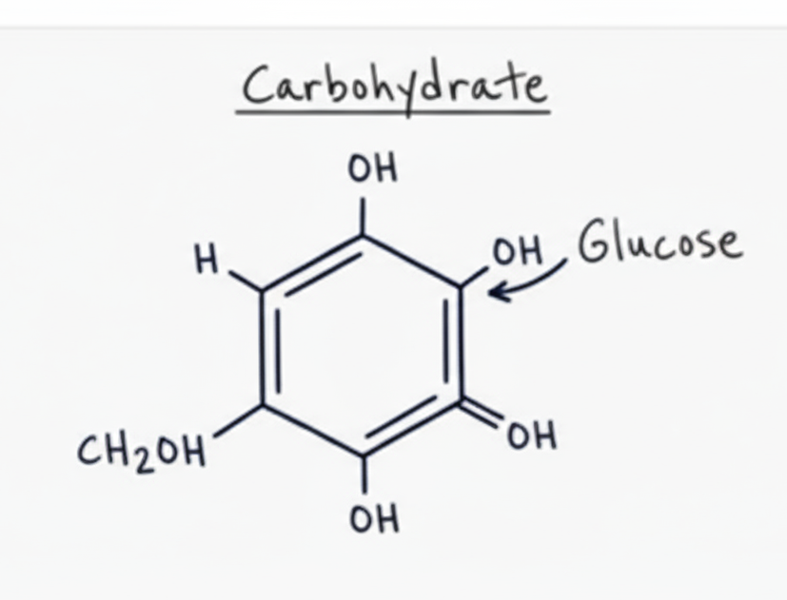
Carbohydrates
Carbohydrates are long chains of simple sugars (monosaccharides). The most common simple sugar is glucose. When two glucose molecules join, they form a disaccharide like maltose. When many glucose molecules link together, they form polysaccharides such as starch, glycogen, or cellulose [1].

- Starch: The primary energy storage carbohydrate in plants.
- Glycogen: The primary energy storage carbohydrate in animals and fungi.
- Cellulose: A structural carbohydrate found in plant cell walls.

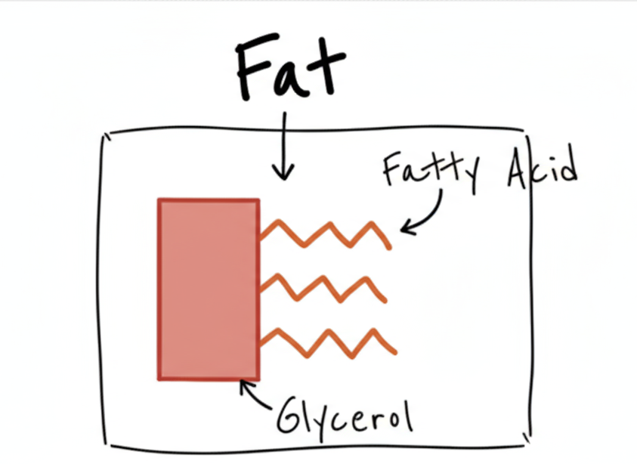
Fats (Lipids)
Most fats are triglycerides, which are composed of one glycerol molecule chemically bonded to three fatty acid chains [1]. Lipids are essential for energy storage, insulation, and as components of cell membranes.

Proteins
Proteins are long chains of amino acids [1]. There are about 20 different types of amino acids, each with a unique 'R' group. The specific sequence and folding of these amino acids determine the protein's unique three-dimensional structure and function. Proteins are involved in virtually all cell functions, including acting as enzymes, structural components, transport molecules, and hormones.

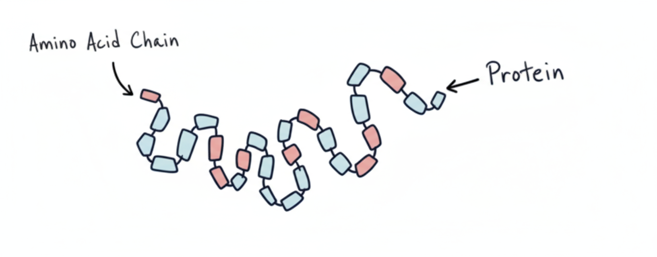

4.2 Food Tests
Food tests are qualitative biochemical tests used to detect the presence of specific biological molecules (carbohydrates, proteins, lipids, and vitamins) in food samples. These tests rely on characteristic color changes when specific reagents are added.

Tests for Carbohydrates

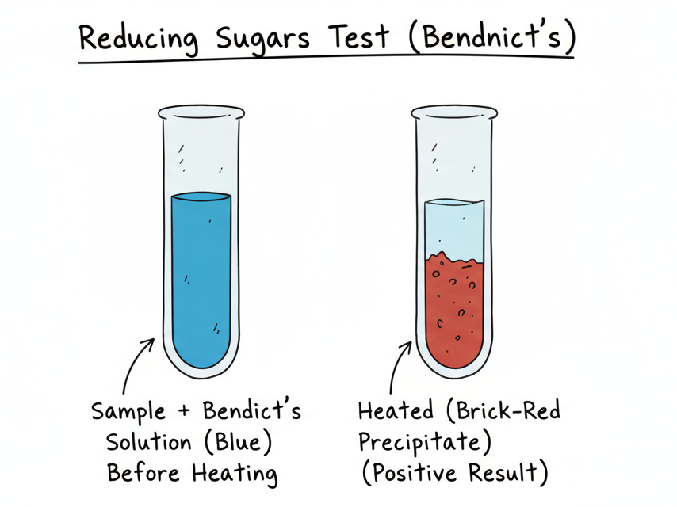
Test for Reducing Sugars (Benedict's Test)
- Reagent: Benedict's solution (blue) [2].
- Procedure: Add Benedict's solution to the food sample in a test tube. Heat the mixture in a water bath.
- Positive Result: Color changes from blue to green, yellow, orange, or brick-red precipitate, depending on the concentration of reducing sugar.
- Negative Result: Solution remains blue.

Test for Starch (Iodine Test)
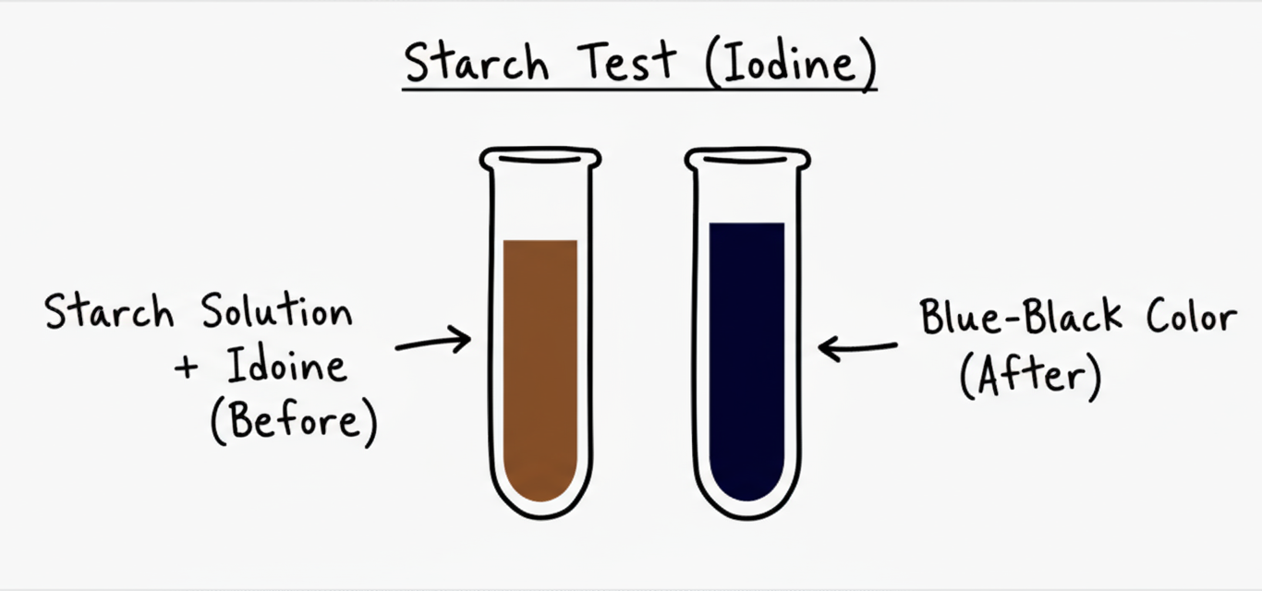
- Reagent: Iodine solution (orange-brown) [2].
- Procedure: Add a few drops of iodine solution directly to the food sample.
- Positive Result: Color changes from orange-brown to blue-black.
- Negative Result: Solution remains orange-brown.

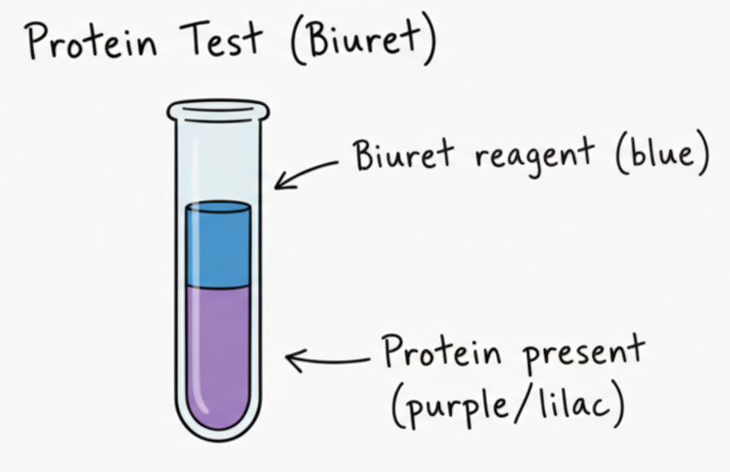
Test for Proteins (Biuret Test)
- Reagent: Biuret solution (blue) [2].
- Procedure: Add a few drops of Biuret solution to the food sample.
- Positive Result: Color changes from blue to violet/purple.
- Negative Result: Solution remains blue.

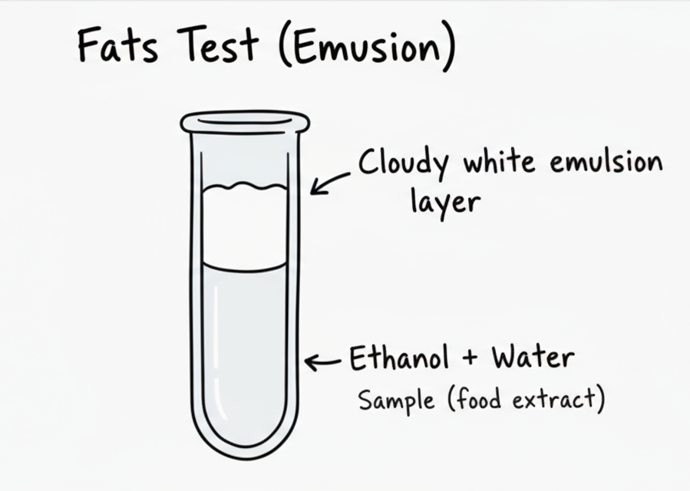
Test for Lipids (Ethanol Emulsion Test)
- Reagent: Ethanol and cold water [2].
- Procedure: Mix the food sample with 2 cm³ of ethanol and shake thoroughly. Pour the ethanol into an equal volume of cold water.
- Positive Result: A cloudy white emulsion forms.
- Negative Result: Solution remains clear.

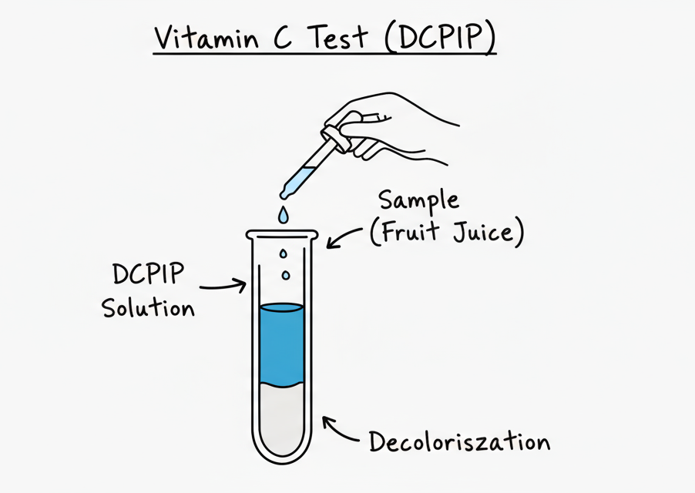
Test for Vitamin C (DCPIP Test)
- Reagent: DCPIP solution (blue) [2].
- Procedure: Add a small amount of the food sample (as a solution) to 1 cm³ of DCPIP solution.
- Positive Result: The blue color of the DCPIP disappears.
- Negative Result: Solution remains blue

4.3 DNA Structure
Deoxyribonucleic acid (DNA) is the molecule of heredity, carrying the genetic instructions for the development, functioning, growth, and reproduction of all known living organisms and many viruses. Its structure is key to its ability to store and transmit genetic information.

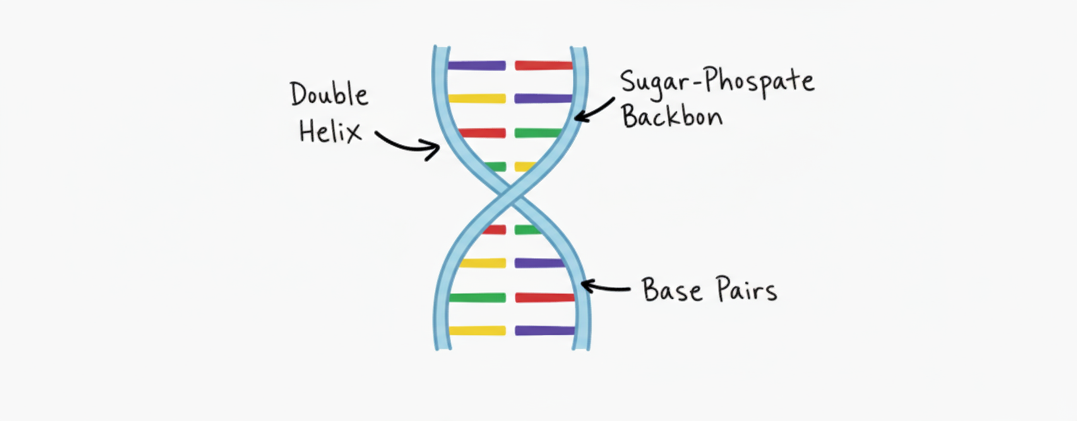

Nucleotides and Bases
DNA has a double helix structure formed by 2 coiled strands. Each strand of DNA is made up of repeating units called nucleotides. A nucleotide consists of three components: a phosphate group, a deoxyribose sugar, and a nitrogenous base [3]. The phosphate and sugar molecules form the backbone of the DNA strand.
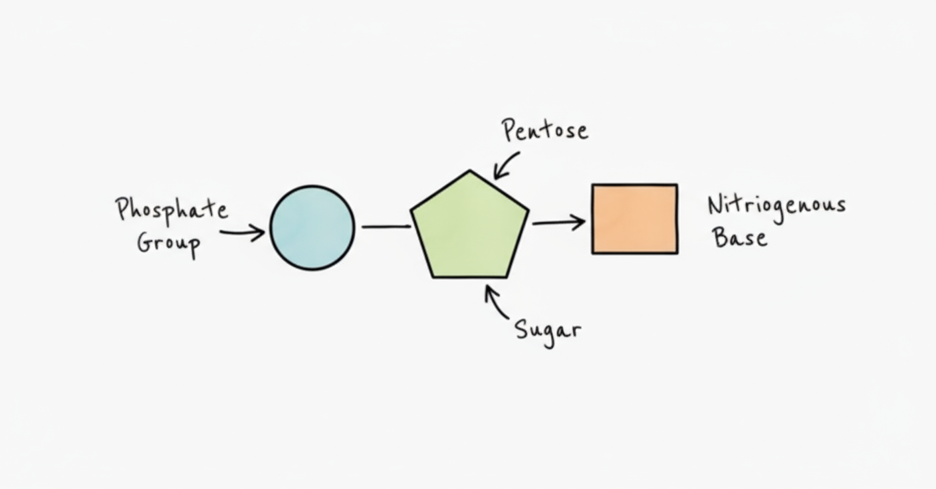
There are four different nitrogenous bases in DNA [3]:

- Adenine (A)
- Guanine (G)
- Cytosine (C)
- Thymine (T)

Complementary Base Pairing
The two strands of the DNA double helix are linked by chemical bonds between the bases. The bases always pair in a specific way, known as complementary base pairing [3]:

- Adenine (A) always pairs with Thymine (T).
- Guanine (G) always pairs with Cytosine (C).

This specific pairing is essential for the accurate replication of DNA and the transmission of genetic information.

Role in Heredity
The sequence of these bases along the DNA molecule forms the genetic code, which determines the sequence of amino acids in proteins. This, in turn, dictates the traits of an organism. The structure of DNA allows it to be accurately copied and passed on from one generation to the next, ensuring the continuity of life.

